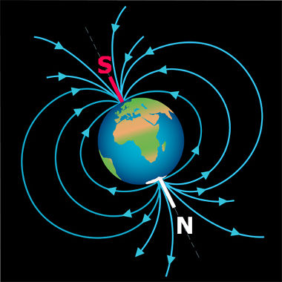
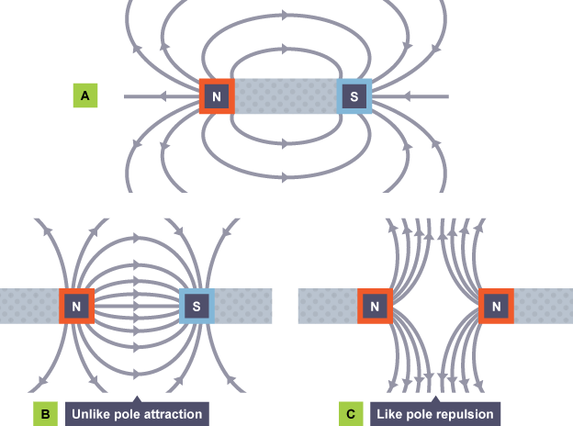
The Earth’s Magnetic field
At the centre of the earth is a molten Iron core.
This is a magnet and produces a magnetic field just like any other magnet.
The same rules apply to drawing this magnetic field, out of North and into South (ON & IS)
A common misconception.
The north of the planet has the south magnetic pole. This means that the north ends of magnets will be attracted to it and point to the North. North ends point north because they are attracted to the south pole of the Earth’s core.
Key points when drawing magnetic field lines.
- The lines leave the South and enter the North, so be careful with arrow heads when drawing them
- The field lines will curve around at the side but become more spread out from the ends
- Learn how to draw the field lines when 2 magnets come together to show how they attract or repel.
- ALWAYS SHOW ARROW HEADS
The magnetic force is a non-contact force. The stronger the magnet and the closer an object is to the magnet, the greater the magnetic force the object will feel.
Magnetic force: Non-contact force from a magnet on a magnetic material.
Permanent magnet: An object that is magnetic all the time.
Magnetic poles: The ends of a magnetic field, called north-seeking (N) and south-seeking poles (S).

You need to know the content of this sheet. 100%
Electromagnetism
Electric charge is a fundamental property of matter everywhere.
100% Sheet
Magnetism

