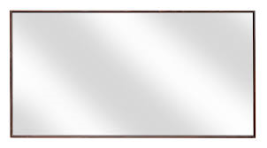
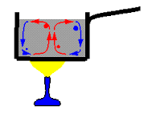
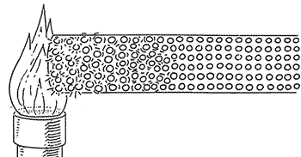
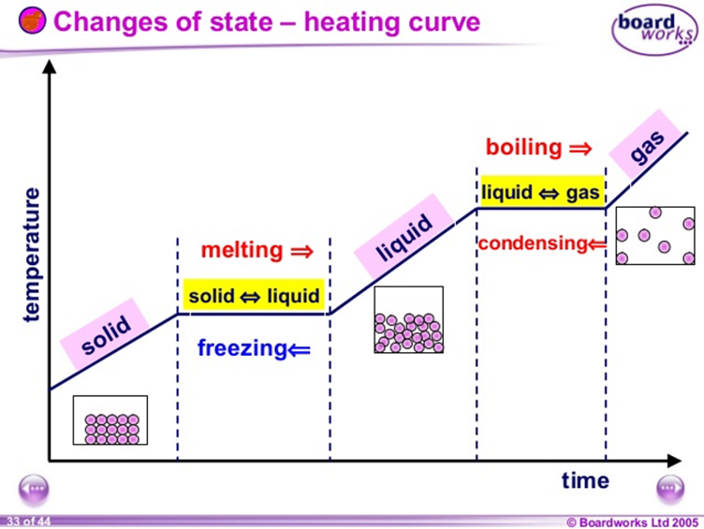
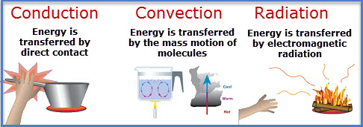
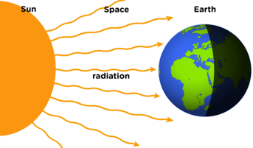
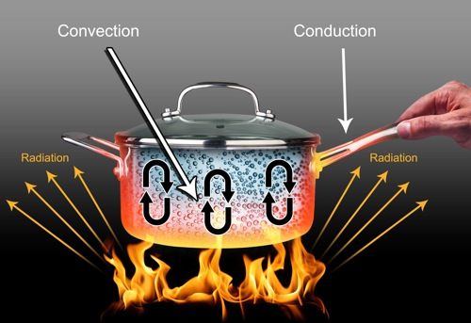
Infrared Radiation and different surfaces

Colour only influences heat transfer by radiation.
Shiny silver surfaces reflect radiation. They are used in flasks and emergency blankets to keep heat in.
Black surfaces absorb and emit radiation

Matt black
Shiny silver
Energy
cannot be created or destroyed, but only moved into another store
You need to know the content of this sheet. 100%
100% Sheet
Heating and Cooling
KEY WORDS to use with Infrared radiation
Radiate or Emit is to give out heat
Absorb is to take in heat
Reflect is to ‘throw back’ the waves without absorbing them
Conduction is the transfer of heat energy through a solid by direct contact of particles moving against each other causing friction and HEAT

Convection is the transfer of heat energy by liquids or gases. Convection currents arise due to hot liquids or gases rising and cold gases or liquids sinking. This is due to a change in DENSITY where less dense liquids and gases rise and more dense liquids and gases sink

Radiation is the transfer of heat energy by electromagnetic waves. They DO NOT involve particles

(a) The table below shows the melting points of four metals.

metal | melting point,  in °C
gold | 1064
mercury | –37
sodium | 98
iron | 1540
(i) Which metal in the table has the highest melting point?
............................................................
1 mark
(ii) Which metal in the table has the lowest melting point?
............................................................
1 mark
(b) Gold can be a gas or a liquid or a solid.
Choose from these words to fill the gaps below.
When gold is heated from room temperature to 1070°C, the gold
changes from a ................................. to a ................................... .
1 mark

Melting, boiling, freezing and condensing are the names of four changes of state.
Draw lines to join each name to the correct change of state.
