B1.2 Animal and plant cells
① REVISE | Collins Trilogy pg.16,24,46  Oxford Biology 3rd pg.6-7

 | Grade 4 | Grade 6 | Grade 8
B1.2 Animal and plant cells | I can identify a plant and animal cell from a diagram. | I can describe the functions of the parts of cells. | I can explain how the main structures of cells are related to their functions.
B1.2 Animal and plant cells | I can name the main parts of cells. | I can compare plant and animal cells. | I can suggest reasons why some cells do not contain all cell structures.

1.1.2 Students should be able to explain how the main sub-cellular structures, including the nucleus, cell membranes, mitochondria, chloroplasts in plant cells and plasmids in bacterial cells are related to their functions.
Most animal cells have the following parts:
a nucleus, cytoplasm, a cell membrane, mitochondria, ribosomes.
In addition to the parts found in animal cells, plant cells often have:
Chloroplasts, a permanent vacuole filled with cell sap.
Plant and algal cells also have a cell wall made of cellulose, which strengthens the cell.
1) Name these parts of the cell
Part | Function
 | Contains genetic material, which controls the activities of the cell
 | Most chemical processes take place here, controlled by enzymes
 | Controls the movement of substances into and out of the cell
 | Most energy is released by respiration here
 | Protein synthesis happens here

2) Name these Extra parts of Plant cells
Part | Function
 | Strengthens the cell
 | Contain chlorophyll, which absorbs light energy for photosynthesis
 | Filled with cell sap to help keep the cell turgid

3) Label these diagrams
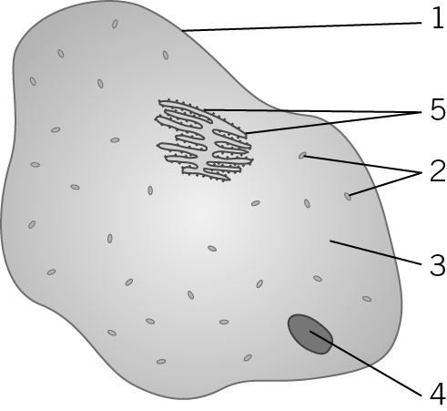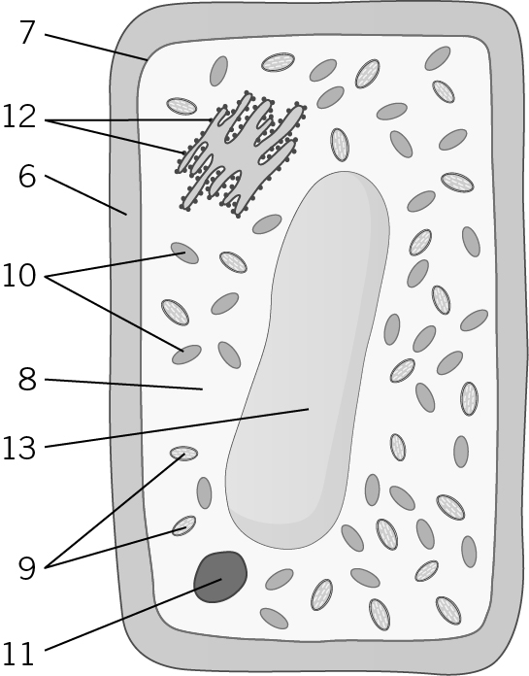
Animal Cell Plant Cell
TEST YOURSELF ②

Grade 4 | What are the main parts of a cell?  …………………………………………………………………………………………………………….  …………………………………………………………………………………………………………….  …………………………………………………………………………………………………………….  …………………………………………………………………………………………………………….  …………………………………………………………………………………………………………….  …………………………………………………………………………………………………………….  …………………………………………………………………………………………………………….  …………………………………………………………………………………………………………….
Grade 6 | What is the difference between an animal and a plant cell?  …………………………………………………………………………………………………………….  …………………………………………………………………………………………………………….  …………………………………………………………………………………………………………….  …………………………………………………………………………………………………………….  …………………………………………………………………………………………………………….  …………………………………………………………………………………………………………….  …………………………………………………………………………………………………………….  What do these parts of the cell do?
  Cell Wall | ……………………………………………………………………………………………………………………………………………………………………
  Cell Membrane | ……………………………………………………………………………………………………………………………………………………………………
  Nucleus | ……………………………………………………………………………………………………………………………………………………………………
  Mitochondria | ……………………………………………………………………………………………………………………………………………………………………
  Ribosomes | ……………………………………………………………………………………………………………………………………………………………………
Grade 8 | Why do muscle cells contain lots of mitochondria?  …………………………………………………………………………………………………………….  …………………………………………………………………………………………………………….  …………………………………………………………………………………………………………….  …………………………………………………………………………………………………………….  …………………………………………………………………………………………………………….  Why don’t roots contain many chloroplasts?  …………………………………………………………………………………………………………….  …………………………………………………………………………………………………………….  …………………………………………………………………………………………………………….  …………………………………………………………………………………………………………….

