B1.3 Eukaryotic cells and prokaryotic cells
① REVISE | Collins Trilogy pg.16-18  Oxford Biology 3rd pg.8-9

 | Grade 4 | Grade 6 | Grade 8
B1.3 Eukaryotic cells and prokaryotic cells | I can identify structures in prokaryotic cells and explain that they do not have a nucleus | I can compare prokaryotic and eukaryotic cells and describe the function of plasmids. | I can explain how the main structures of prokaryotic cells are related to their functions.
B1.3 Eukaryotic cells and prokaryotic cells | I can use orders of magnitude to correctly order objects according to size. | I can use orders of magnitude to compare sizes of organisms. | I can perform calculations to work out orders of magnitude.

1.1.1 Plant and animal cells (eukaryotic cells) have a cell membrane, cytoplasm, and genetic material enclosed in a nucleus. Bacterial cells (prokaryotic cells) are much smaller in comparison. They have cytoplasm and a cell membrane surrounded by a cell wall. The genetic material is not enclosed in a nucleus. It is a single DNA loop and may have one or more small rings of DNA called plasmids.
Students should be able to demonstrate an understanding of the scale and size of cells and be able to make order of magnitude calculations, including the use of standard form.
1.1.2 Students should be able to explain how the main sub-cellular structures, including the nucleus, cell membranes, mitochondria, chloroplasts in plant cells, and plasmids in bacterial cells are related to their functions.

1) Label this diagram of a prokaryote using these keywords
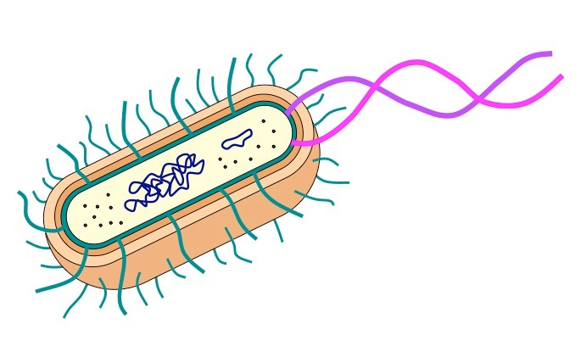
Cytoplasm
Cell Membrane
Cell Wall
DNA Chromosome
Plasmid
Flagella

2) Name these parts of a prokaryote
Part | Function
 | A large ring of DNA that contains most of the genes of the prokaryote
 | A small ring of DNA that contains a few genes and can be exchanged with other prokaryotes
 | Long proteins strands used by the bacteria to move themselves around
 | Controls the movement of substances into and out of the cell
 | Protein synthesis happens here

3) Complete these instructions to work out an “order of magnitude”

To make an order of magnitude calculation for two numbers you should ………. the big number by the small number.
If the answer is less than 10 then the numbers are the same…………………………………
If the answer is more than 10 then the bigger number is …………. order of magnitude bigger
If the answer is more than 100 then the bigger number is ……………… orders of magnitude bigger
If the answer is more than 1000 then the bigger number is ………………. orders of magnitude bigger
TEST YOURSELF ②

Grade 3 | Label one of these a prokaryote and the other a eukaryote  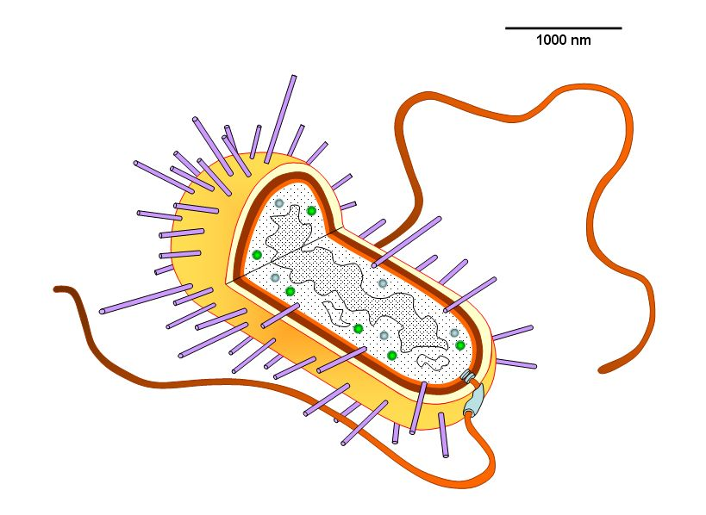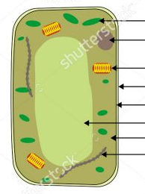  Cell A Cell B  Explain your choice  …………………………………………………………………………………………………………….  …………………………………………………………………………………………………………….  …………………………………………………………………………………………………………….  …………………………………………………………………………………………………………….  The cell on the right is an order of magnitude bigger than the cell on the left. Which cell is bigger?
Grade 6 | Look at this diagram of a yeast cell. Is a yeast cell 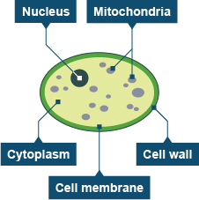  a eukaryote or prokaryote? Explain your answer.  Give as many pieces of evidence as you can.  …………………………………………………………………………………………………………….  …………………………………………………………………………………………………………….  …………………………………………………………………………………………………………….  …………………………………………………………………………………………………………….  …………………………………………………………………………………………………………….  …………………………………………………………………………………………………………….  …………………………………………………………………………………………………………….  …………………………………………………………………………………………………………….  Where would you find a plasmid and what is it?  …………………………………………………………………………………………………………….  …………………………………………………………………………………………………………….  …………………………………………………………………………………………………………….  …………………………………………………………………………………………………………….
Grade 8 | A human skin cell is about 30 μm.  An E.coli bacteria is an order of magnitude smaller than a skin cell. How big is an E.Coli?...........  An HIV virus is two orders of magnitude smaller than an skin cell. How big is an HIV virus?.........  A human egg is 100 μm. How many orders of magnitude bigger is an egg cell than a skin cell?.....

