B1.7 &1.8 Osmosis
① REVISE | Collins Trilogy pg.22-23  Oxford Biology 3rd pg.16-19

 | Grade 4 | Grade 6 | Grade 8
B1.7 & 1.8 Osmosis | I can describe what osmosis is. | I can state the differences between osmosis and diffusion. | I can explain how a model shows osmosis in a cell.
B1.7 & 1.8 Osmosis | I can state that if animal cells lose or gain too much water by osmosis they can stop working properly. | I can use ideas about osmosis to explain why maintaining constant internal conditions in living organisms is important. | I can use the terms isotonic, hypotonic or hypertonic to explain the movement of water across a cell membrane.
B1.7 & 1.8 Osmosis | I can state that if a plant loses too much water from its cells they become soft. | I can use use osmosis to explain the effect of placing plant tissue in salt or sugar solutions. | I can explain the mechanisms that lead to turgid or flaccid plant cells and plasmolysis.

1.3.2 Water may move across cell membranes via osmosis.
Osmosis is the diffusion of water through a partially permeable membrane from a dilute solution to a concentrated solution.
Students should understand and use the terms isotonic, hypotonic, and hypertonic.
5.3.3 If body cells lose or gain too much water by osmosis they do not function efficiently.
1) Match the keyword to its meaning
Diffusion |  | A membrane that will allow water to pass through but will block many larger molecules
Semi Permeable membrane |  | When particles spread out through the random movement of particles
Osmosis |  | When a solution has the same concentration of sugar or salt as the body
Isotonic |  | When water moves through a partially permeable membrane to dilute a solution at a higher concentration
Hypertonic |  | A solution at a higher concentration that the body or cell
Hypotonic |  | A solution at a lower concentration that the body or cell
2) Look carefully at these diagrams and draw an arrow to show the direction that the water moves
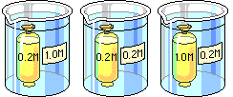
3) Match up the explanation of what happens to a cell in different solutions
Isotonic |  | Water moves into the cell because the concentration of ions and sugars is higher inside the cell.
Hypertonic |  | Water moves out of the cell because the concentration of ions and sugars is higher outside of the cell.
Hypotonic |  | The water is moving in and out of the cell at an equal rate because the concentration of sugar and ions inside and outside the cell is equal.
4) Three cells were placed in either hypotonic, hypertonic or isotonic solution. Label which is which
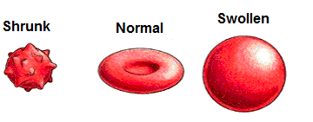
TEST YOURSELF ②

Grade 3 | What is osmosis?  ……………………………………………………………………….…………………………………………………………………………………………………………….………………………………………...  What happens to animal cells if they lose too much water?  ……………………………………………………………………….…………………………………………………………………………………………………………….…………………………………….……
Grade 6 | Why would drinking sea water (which has a hypertonic salt solution) lead to dehydration?  ……………………………………………………………………….…………………………………………………………………………………………………………….………………………………………………………………………………………………………………….………………………………....……  Why do your fingers go wrinkly in the bath but not in the sea?  ……………………………………………………………………….…………………………………………………………………………………………………………….………………………………………………………………………………………………………………….………………………………....……  Why do plants go flaccid when you put them in salt water  ……………………………………………………………………….…………………………………………………………………………………………………………….………………………………………………………………………………………………………………….……………………………....………
Grade 8 | 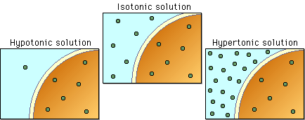  Do the dots represent water or ions? Explain your answer by referring to the diagram  ……………………………………………………………………….…………………………………………………………………………………………………………….………………………………………………………………………………………………………………….…………………………………………………………………………………………………………….………………………………  Explain what direction the water will move in each diagram.  ……………………………………………………………………….…………………………………………………………………………………………………………….………………………………………………………………………………………………………………….…………………………………………………………………………………………………………….………………………………  If the ions could move through the membrane what would happen?  ……………………………………………………………………….…………………………………………………………………………………………………………….………………………………………………………………………………………………………………….…………………………………………………………………………………………………………….………………………………
Grade 8 | This diagram shows a plant cell placed into a strong salt solution. Explain what is happening.  ……………………………………………………………………….…………………………………………………………………………………………………………….………………………………………………………………………………………………………………….…………………………………………………………………………………………………………….…………………………………………………………………… | 