B1.4 Specialisation in animal cells
① REVISE | Collins Trilogy pg.24-25,28  Oxford Biology 3rd pg.10-11

 | Grade 4 | Grade 6 | Grade 8
B1.4 Specialisation in animal cells | I can identify specialised animals cells from diagrams. | I can explain why animals have specialised cells. | I can discuss how the structure of specialised animal cells are related to their function within the organ and whole organism.
B1.4 Specialisation in animal cells | I can describe the function of specialised animal cells. | I can compare the structure of a specialised and generalised animal cell. | I can suggest and explain the function of an unknown specialised cell based on its structure.

1.1.3 Students should be able to, when provided with appropriate information, explain how the structure of different types of cell relate to their function in a tissue, an organ or organ system, or the whole organism.
Cells may be specialised to carry out a particular function: sperm cells, nerve cells, and muscle cells in animals, 2.2.3 Red blood cells contain haemoglobin which binds to oxygen to transport it from the lungs to the tissues.
1) Name these cells
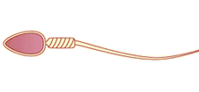 | 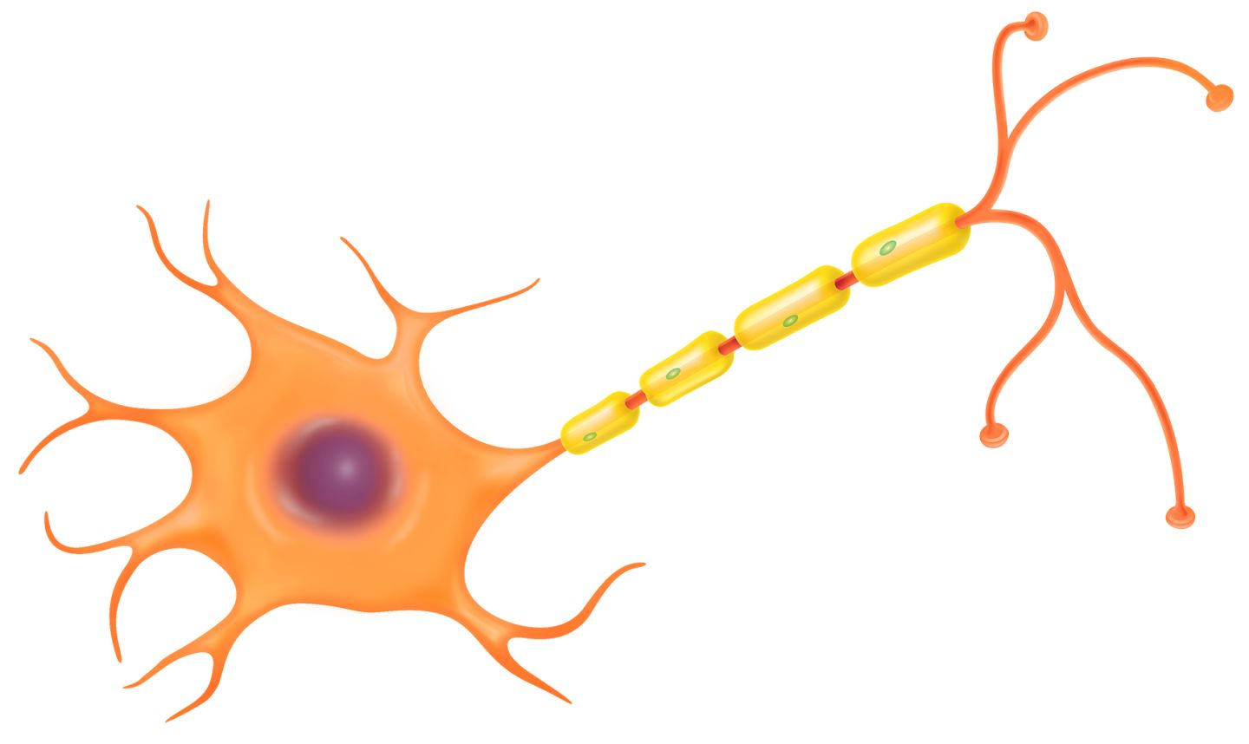 | 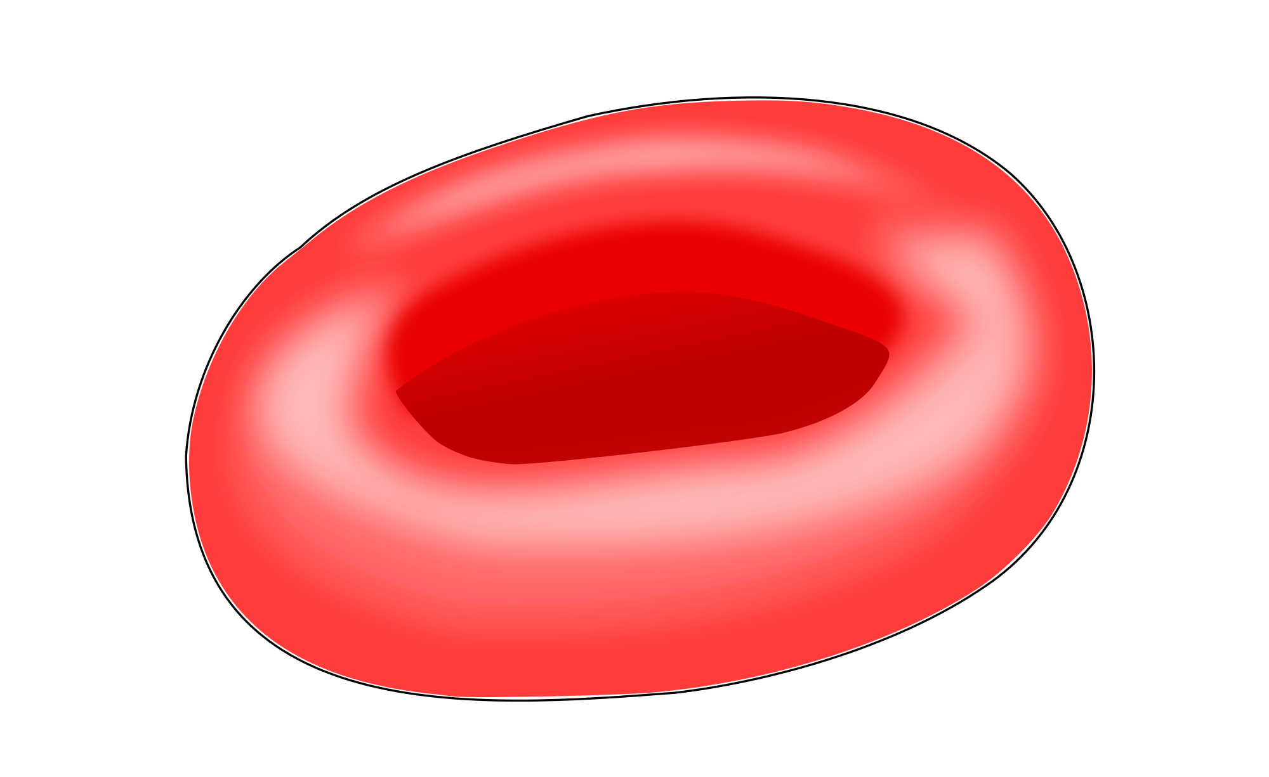 | 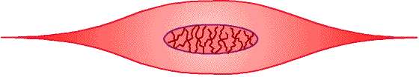
2) Name these cells from their function and adaptation
Type of cell | Function | Features of cell that allow it to perform its function
 | Contracts to allow movement of body parts | Contains long protein filaments that can slide past each other to shorten the cell. They contain many mitochondria to provide energy.
 | Transmits electrical impulses from one part of body to another | Contain membrane proteins that carry out active transport of sodium and potassium ions to help 'recharge' the cell.
 | Carries oxygen to body tissues that require it | Contains the protein haemoglobin, which binds oxygen. Has no nucleus so there is more space available to carry oxygen
 | Transfers genes from male body to female gamete during sexual reproduction | Has a tail to allow it to swim to egg cell and contains many mitochondria to supply energy. Its head contains enzymes that are released to help it break through the outer membrane of the egg cell
3) Match these keywords to their definitions
Cell |  | The simplest unit of life
Tissue |  | A group of organs working together
Organ |  | A group of tissues that work together for a particular function
Organ system |  | Many cells of the same type
4) Describe how adaptations of muscle cells allow the body to move quickly
…………………………………………………………………………………………………………….
…………………………………………………………………………………………………………….
…………………………………………………………………………………………………………….
TEST YOURSELF ②

Grade 3 | What is the function of……..  A muscle cell  …………………………………………………………………………………………………………….  …………………………………………………………………………………………………………….  …………………………………………………………………………………………………………….  A nerve cell  …………………………………………………………………………………………………………….  …………………………………………………………………………………………………………….  …………………………………………………………………………………………………………….  A sperm cell  …………………………………………………………………………………………………………….  …………………………………………………………………………………………………………….  …………………………………………………………………………………………………………….
Grade 6 | Describe the difference between a typical animal cell like this and the cells shown to the right. To do this you will have to describe the adaptations of each cell. | 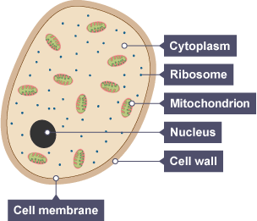
Grade 6 | ……………………………………………………………………  ……………………………………………………………………  …………………………………………………………………… | 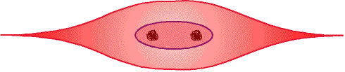
Grade 6 | ……………………………………………………………………  ……………………………………………………………………  ……………………………………………………………………
Grade 6 | ……………………………………………………………………  ……………………………………………………………………  ……………………………………………………………………
Grade 8 | Describe the function of the cell shown to the right and explain how it is adapted to serve this function. …………………………....………………………………………  ……………………………………………………………………  …………………………………………………………………………………………………………………………………………  ……………………………………………………………………  …………………………………………………………………… | 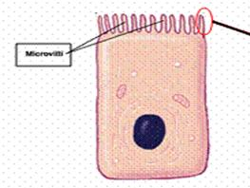  This is a cell from the lining of the intestine. The job of the intestine is to absorb water and nutrients from the gut. This cell. is covered in tiny “microvili”. These microvili give the cell a very big surface area.

