
  Motion Higher
  Name: | ________________________
  Class: | ________________________
  Date: | ________________________
Time: | 30 minutes
Marks: | 29 marks
Comments:

Q1.This question is about speed.
(a) What is a typical value for the speed of sound?
Tick one box.

 | 3.3 m / s | 
 | 3.3 × 10² m / s
 | 3.3 × 10³ m / s
 | 3.3 × 10⁶ m / s
(1)
(b) Figure 1 shows a distance–time graph of a car.
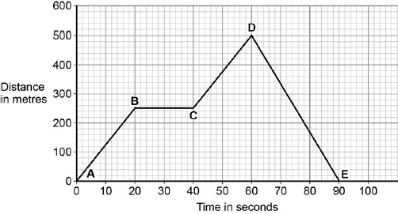
Explain what Figure 1 shows about the motion of the car between point A and point E.
You should use values from Figure 1 in your answer.
........................................................................................................................
........................................................................................................................
........................................................................................................................
........................................................................................................................
........................................................................................................................
........................................................................................................................
........................................................................................................................
........................................................................................................................
(4)

(c) The kinetic energy of a moving car depends on the car’s mass and speed.
Write down the equation that links kinetic energy, mass and speed.
........................................................................................................................
(1)

(d) A car has a mass of 1 650 kg.
The table below shows the kinetic energy of the car moving at 11 m / s.

 | Mass of car in kg | Speed in m / s | Kinetic energy in J
 | 1 650 | 11 | 99 825
 | 1 650 | 30

Calculate the missing value in the table above.
Give your answer in kilojoules (kJ).
........................................................................................................................
........................................................................................................................
Kinetic energy = .................................. kJ
(2)
(e) A man is driving his car at a constant speed on a wet road.
He sees a fallen tree on the wet road and tries to stop quickly to prevent an accident.
Figure 2
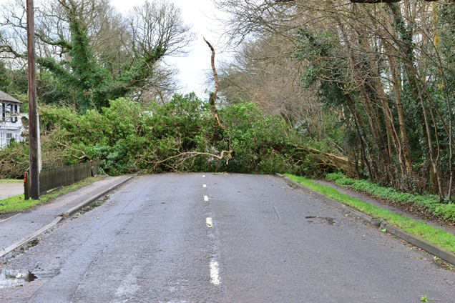
© Paul-Briden/iStock/Thinkstock

Explain why the man may not be able to stop in time.
........................................................................................................................
........................................................................................................................
........................................................................................................................
........................................................................................................................
........................................................................................................................
........................................................................................................................
........................................................................................................................
........................................................................................................................
........................................................................................................................
........................................................................................................................
(6)
(Total 14 marks)

Q2. A car travelling along a straight road has to stop and wait at red traffic lights. The graph shows how the velocity of the car changes after the traffic lights turn green.
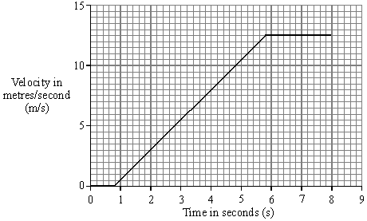
(a) Between the traffic lights changing to green and the car starting to move there is a time delay. This is called the reaction time. Write down one factor that could affect the driver’s reaction time.
.............................................................................................................................
(1)
(b) Calculate the distance the car travels while accelerating. Show clearly how you work out your answer.
.............................................................................................................................
.............................................................................................................................

Distance = ...............................................metres
(3)

(c) Calculate the acceleration of the car. Show clearly how you work out your final answer and give the units.
.............................................................................................................................
.............................................................................................................................
.............................................................................................................................
Acceleration = ...................................................................
(4)
(d) The mass of the car is 900 kg.
(i) Write down the equation that links acceleration, force and mass.
...................................................................................................................
(1)
(ii) Calculate the force used to accelerate the car. Show clearly how you work out your final answer.
...................................................................................................................
...................................................................................................................
Force = ..................................................... newtons
(2)
(Total 11 marks)
Q3.The London Eye is one of the largest observation wheels in the world.
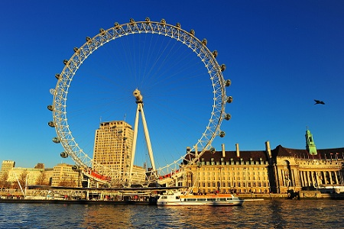
© Angelo Ferraris/Shutterstock
The passengers ride in capsules. Each capsule moves in a circular path and accelerates.
(a) Explain how the wheel can move at a steady speed and the capsules accelerate at the same time.
........................................................................................................................
........................................................................................................................
........................................................................................................................
(2)
(b) In which direction is the resultant force on each capsule?
........................................................................................................................
(1)
(c) The designers of the London Eye had to consider three factors which affect the resultant force described in part (b).
Two factors that increase the resultant force are:
• an increase in the speed of rotation
• an increase in the total mass of the wheel, the capsules and the passengers.
Name the other factor that affects the resultant force and state what effect it has on the resultant force.
........................................................................................................................
........................................................................................................................
(1)
(Total 4 marks)

